Kickstarter Analysis

# Overview of Project

Purpose:

To perform data analysis on several thousand crowdfunding projects to identify possible trends allowing Louise to make an informed decision on her campaign strategy.

## Background

* Louise is a Playwriter looking to crowd fund a play in the US
* Her project campaign, a play named *Fever* came close to reaching its fundraising goal in a short span of time
* She requires assistance with data based on statistical facts in order to make an informed decision on her campaign strategy.
* Louise is focused on creating a play in the US, she is also interested in Great Britain’s theatre market, particularly musicals
* Oct 2010 to Feb 2017 crowd sourcing data was provided for the purpose of trend analysis

# Analysis and Challenges

## Analysis of Outcomes Based on Launch Date

The peak season for launching a theater production is between the months of May to August. This peak season represents 42% of yearly theater productions which is consistent both globally and for the United States. This trend has been consistent from 2014 onward with successful outcomes for plays averaging 64% in the US 4% lower than the global average 4%.

While overall data would indicate that May yields the highest for theater productions in terms of ‘successful’ launch month. See Chart 1. This can vary from year to year as seen in Table 1. This trend is consistent when drilled down to US specific plays only data.

### Chart 1

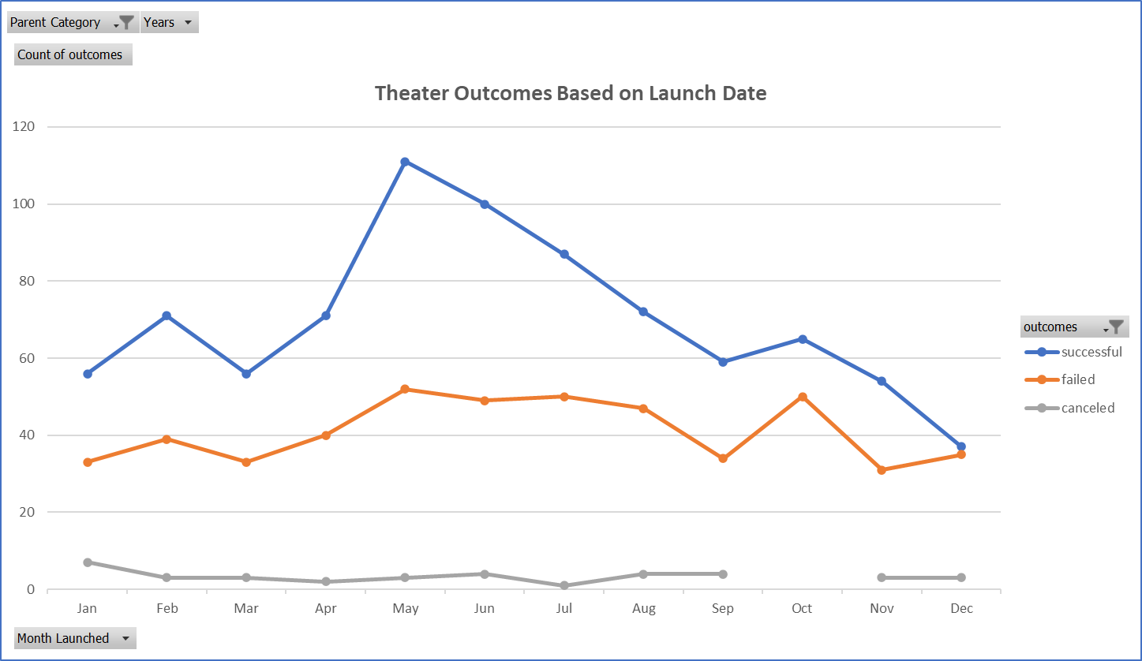

### Table 1 **Peak vs Non-Peak Season for Successful Theatre Productions**



Using only the last 3 full calendar years, it would be advisable to launch a US play within the identified ‘peak season’ of May through August. Note: that the month of May has consistently demonstrated the highest percentage of successful US play results. See Table 2.

### Table 2 **Annual % of Successful Plays Launched Annually**



## Analysis of Outcomes Based on Goals:

Globally, Kickstarter campaigns with a goal of under $5,000 are on average 74% successful. Campaigns under $10,000 represent 85% of all projects launched. See Table 3 with Chart 2

*\*Assumption has been made that all financial columns are in converted US $.*

### Table 3



### Chart 2

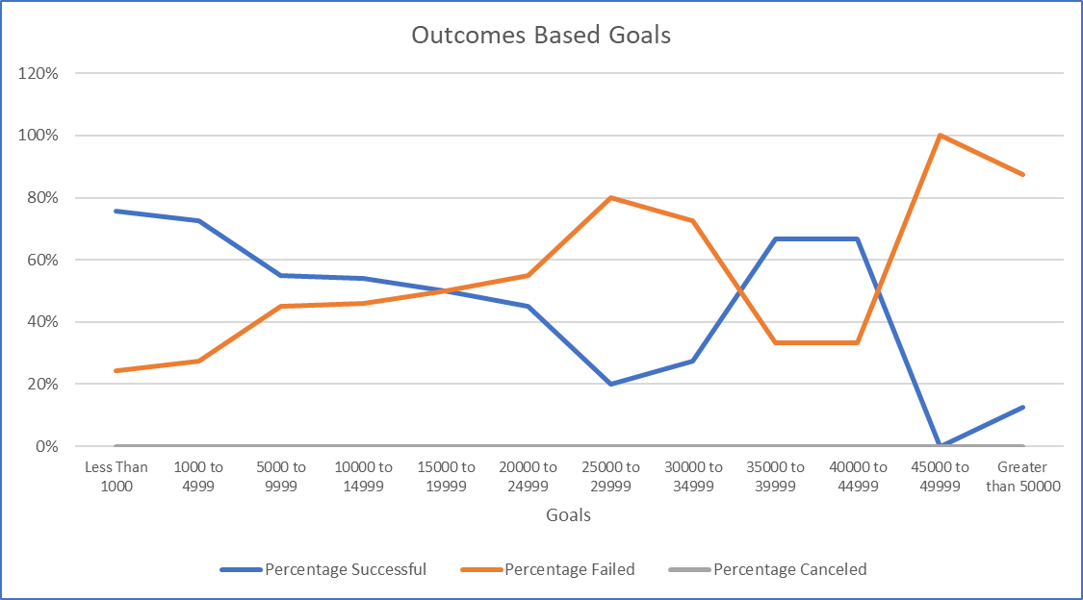

While goals and funding pledged saw a dramatic spike in 2014 for plays in the US and pledges outpacing goal targets averaging 15% the last 3 years (2014-2016) with trends show that there is a decline in both goals and funding year over year. 2015 to 2016 saw a decline of 48.8% in pledged funds.

### Chart 3

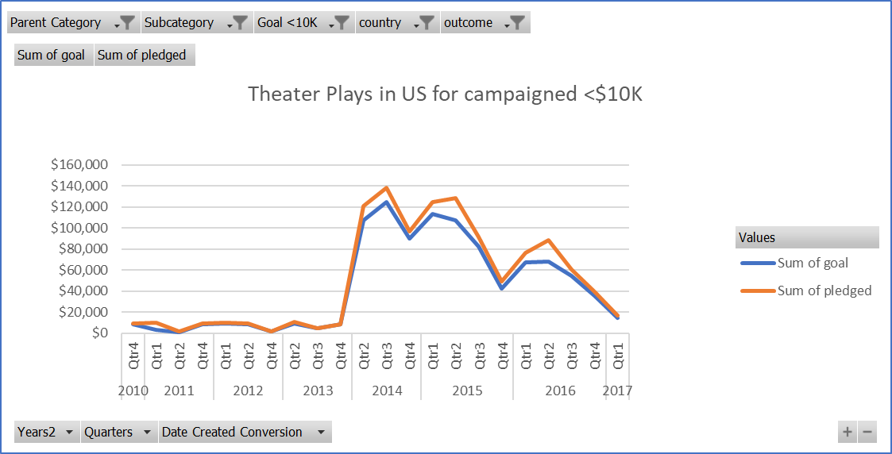

Goal and pledge amounts have been increasing or flat year over year since 2014; however, the number of backers to support a play has seen continued decrease. This coupled with the dramatic increase in launched plays in the US could equate to greater competition for pledge funds to meet goals. A greater need to increase the average size of donations will be needed to offset few backers.

Table 4



For 2014, 2015 and 2016, of the 62% success plays launched in the US, those plays which had a spotlight exceeded goal targets by + 14%.

### Table 5

## 

## Challenges and Difficulties Encountered

Challenges I encountered were attempting to nest an IFS statement with the MEDIAN, INTERQUARTILE functions. While I made the attempt, I was not able to figure out how to do this. To overcome a subset of the raw data was needed, i.e., Successful vs Failed sheets. While this is a decent fix, it makes for a very business workbook and potential for human error in the copy & paste function.

# Results

## Summary

Recommended strategy for launching a US play is as follows:

* launched in ‘peak’ season (May through August)
* Limit campaign’s goal targets to < $5000
* Have play on spotlight
* Be conscious of more competition, i.e., fewer backers per play. Greater focus on higher donations required

## What are two conclusions you can draw about the Theater Outcomes by Launch Date?

Two conclusions that can be drawn from the Theater Outcomes by Launch Date are:

* 1. While data provided ranged from October 2010 through to Feb 2017, the 3 most complete years of 2014, 2015 and 2016 provided the most valuable data for analysis. For successful theater productions, these years had an average monthly count of 24 productions; whereas, 2013 or before yielded less than 2 productions.
  2. There is a distractive ‘peak’ and ‘low’ season to theater productions. A higher volume and percentage of successful productions were yielded during this ‘peak’ season between the months of May and August year over year. This trend was more noticeable when drilled down by country ‘US’ or subcategory ‘plays’

## What can you conclude about the Outcomes based on Goals?

Based on the Outcomes based on Goals, you can conclude the following:

* Those campaigns with target goals under 5000 are most likely to succeed with an average of 74%
* There were no cancelled plays in the US
* The higher the campaign goal the more likely to fail

## What are some limitations of this dataset?

Some limitations to the dataset are:

* Without knowledge of how to convert the deadline and Launched columns of the Kickstarter dataset, the Analyst may not be able to convert into reader friendly dates
* A better understanding behind the meaning of specific columns such as “staff-pick” and “spotlight”, i.e. How does this impact on successful outcomes etc.
* The “Currency” noted on the dataset has not been standardized; therefore, an assumption has been made to all financial columns such as “goal”, “pledge” and “average donation” that this is the case. Clarification is needed to the data what exactly is reflected in the dataset. If currency noted is that noted in the “currency” column, proper analysis would convert all funds into one common US $ for proper analysis.
* Range provided has some partial years, which can skew data when grouped by dates/time series.

## What are some other possible tables and/or graphs that we could create?

Other possible tables and/or graphs that could be used are:

* Table identifying variance and relevance in yearly productions volumes launched from year to year. See Table 1
* Table identifying ‘peak’ and ‘low’ periods for theater productions. See Table 2
* Table identifying success of plays which had a spotlight. See Table 5